32 Servo Controller Manual

Servo controller illustrated in the following description:
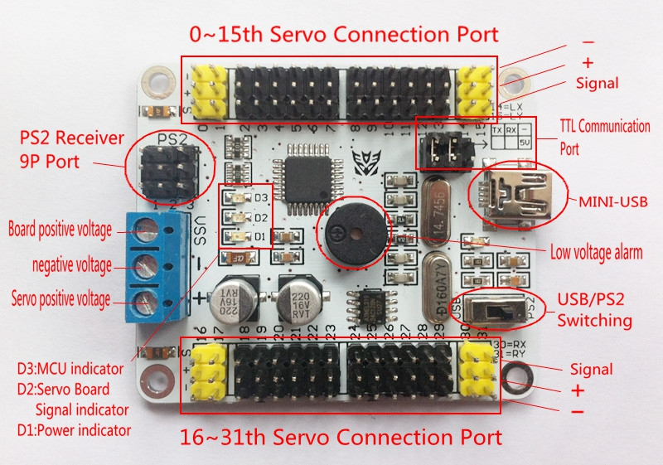
1) Install the driver
See "Drive" folder, follow the instructions inside their own operations.
2) PC software page Detail
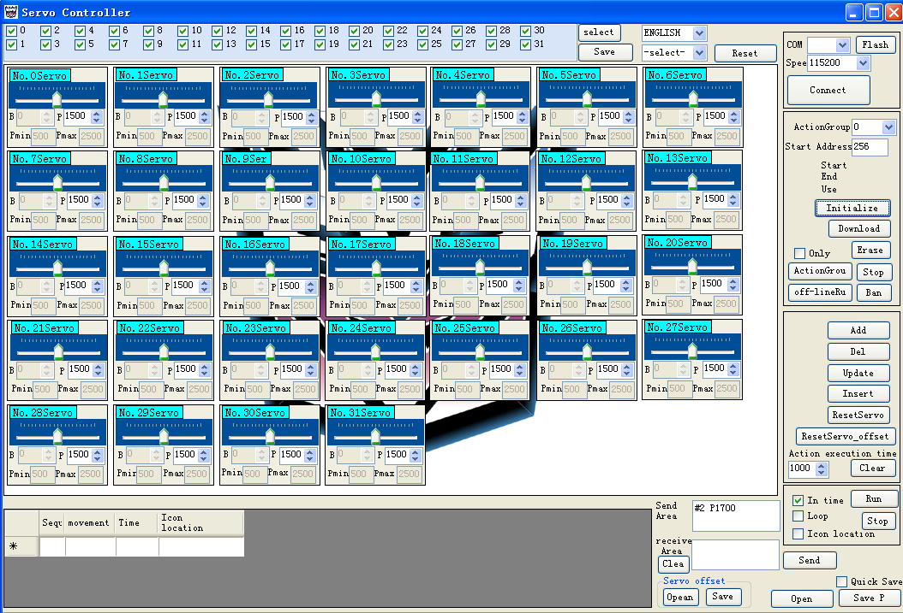
To the left of the steering gear icon in the operating window, tick displays the steering mouth, Cancel closes the mouth of the steering gear.
Servos save icon positions below the window, steering gear icon freely drag after drag save location.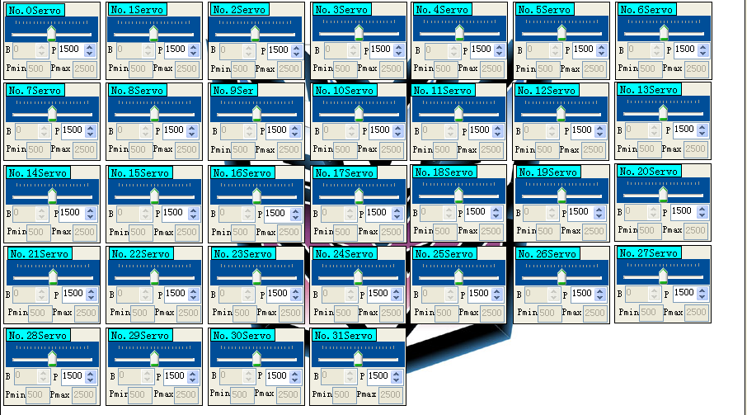
Select the COM port side, the default communication speed of high-speed mode 115200.
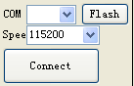
Action group commissioning window.
Add : Add the servo action
Del : Delete the servo action
Update : that is to modify and replace the previous action
Insert : that between the action to insert a new action
Reset : All servo steering becomes P1500 states that the median
ResetServo_offset: Reset the servo offset
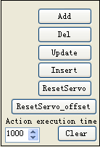
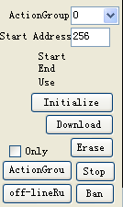
Initialize :PC software initialization, which means that the action began to write the address number 256 position from the start, but the operation of the software, without changing the action has been downloaded to the board.
Erase: for download to the motherboard to make clear the action group operations.
ActionGroup: Run has been downloaded to the board action groups.
Stop: Stop the run action group.
Offl-lineRun: Run has been downloaded to the board action groups, and the next boot directly
to the implementation of the action group.
Ban: Disable Offline Action Group Function
You can easily drag the slider.
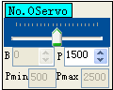
B: bias servo (default is 0), the relative position of the steering gear range is -100 ---- 100
P: position servo (the default is the median 1500) in the range of 500-2500
The operation of the group introduced into the absolute position P0 = B + P
# Indicates the number of steering, P represents the position of the steering gear, T represents the time of the operation of the servo position.
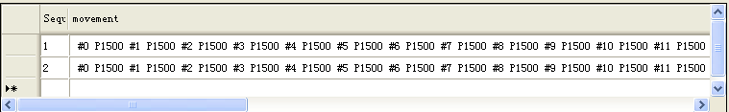
Debugging a good steering deviation B and action files P, B and P require separate save, open use also needs to operate independently, can not open the file with P B Saved open window. Files are saved in XML format.
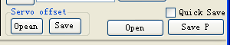
3）Servo board power description
Supply voltage (VSS) : connected 7V-12V, when the VSS voltage is below 7 V, the buzzer alarm to alert the user to charge. (USB can be used to power the chip on servos board. And it can be chosen automatically. With the USB reverse protection, it can protect your computer from been hurted by the reverse USB.)
Supply voltage (+): then 5 ~ 8 V, Li-ion battery-powered model aircraft generally use 7.4V.
Supply voltage (-) :connected to the negative power. VSS and + negative to common ground.
4）Software Description Introduction
Double-click to open the PC software
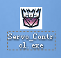
Click here to refresh, and then select the latest out of the COM port and click Connect.
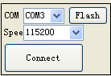
Switch to the USB Mode.
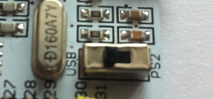
Servos connected to a port on the steering gear, such as steering the 31st pick in the mouth (pick this place to facilitate the testing PC software is also easy to test the joystick).
For example, to select only No.31 servo.
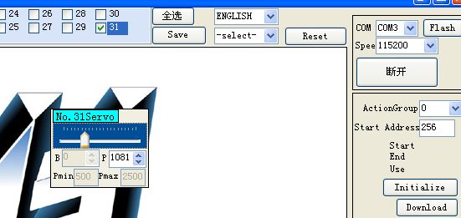
Then drag the left and right steering No. 31, this time communication indicator D 2 (red lights) will follow the synchronous flashing and turn the rudder opportunity to follow around.
Pushed to the left, and then add the following:
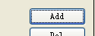
Click the Add action, the emergence of a movement here:
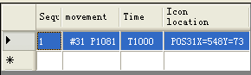
Pushed to the right, and then add the action.
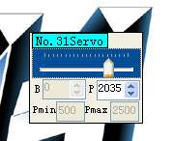
This position appears another action
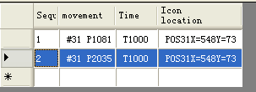
Click on the file Run after a good debugger can run the action.
√ cycle is marked cycle this action group
You can also click the bottom right corner to save
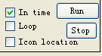
PC software Initialize action group is initialized, the action group is from 0, the address from the 256 began to write.Usually the first time when the need to use the control panel click once initialized, and then download it. If in the future use, erasing finished internal procedures also need to click initialization, easy to download again.
Click
Click to download 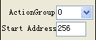
Select 0
Steering board above the red light flashes .
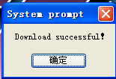
So this action will be downloaded to the action group number 0
At this time, the action group to become an action group, has become the starting address 489 (described here address the action group 0 is 256-497, and the action set a start downloading from the 489, if you overwrite the previous address will make the action group failure, So do not modify the starting position）

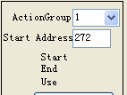

Re-select the action group number 0 (This step is very important)
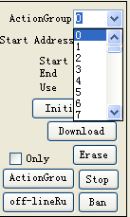
Click the "Actiongroup" for testing. (Erase: that has been downloaded to the steering board above the action group deleted.)
Then we can use the handle to call the action group.
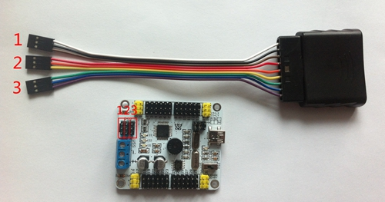
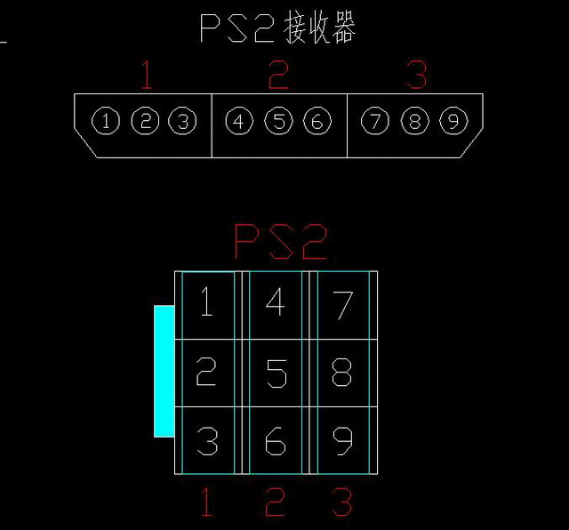
PS2 interfaces 9P Line Interface Description (receiver board with numbers 1-9 1-9, need to work one to one)
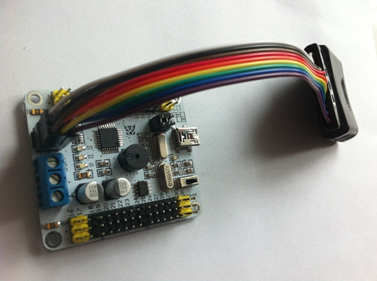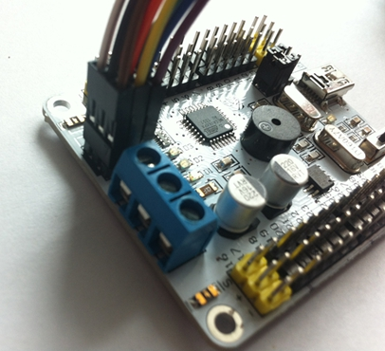
Switch to the PS2 Mode.
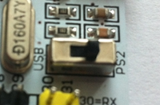

This time, turn the power switch on the handle, you can save a good PC software to extract the action group. Because the front spoke steering received the 31st position after turning on the power to do so as long as the connection is direct drag down the right stick can drive 31 servos turn around
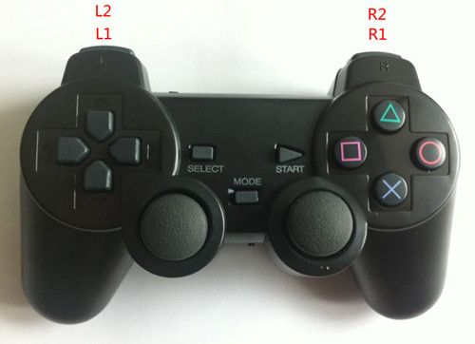

PS2 handle decoding table below:
SELECT  + START | The default mode for the action group (press the button to perform an action group, release the button to stop the action group) / 2 modes of 6-DOF single servo trimming mode (this feature can be used 6-DOF manipulator control) 0,1, 2 8,9 servos | Each time you press SELECT + START to switch a working model of two kinds of operating modes
START | The first set of actions to run under the action group 0 mode, the speed is initialized, the next single servo steering trimming mode 0,1,2 16,17,18 number reset.
Ago | Run Group 1 action group / steering Forward # 0 | ↑
After | Run Group 2 action group / steering reverse number 0 | ↓
Left | The first run 3 Group action group / 1 Servo Forward | ←
Right | The first run 4 group action group / 1 Servo reverse | →
△ | The first run 5 group action group / 16 steering gear forward | △
× | The first run 6 group action group / 16 servo reversing | ×
□ | The first run 7 group action group / 17 servos Forward | □
O | The first run 8 group action group / 17 servos Forward | O
L1 | Section 9 action group run / 2 servos Forward
R1 | The first set of actions set to run 10/18 steering gear forward
SELECT +△ | The first run 11 group action group | First press SELECT, then press △
SELECT +× | The first run 12 group action group | First press SELECT, then press ×
SELECT +□ | The first run 13 group action group | First press SELECT, then press □
SELECT + O | The first run 14 group action group | First press SELECT, then press O
SELECT +L1 | Run Section 15 action group | First press SELECT, then press L1
SELECT +R1 | Run 16 group action group | First press SELECT, then press R1
L2 | Action group deceleration / 2 Servo reverse
R2 | Action group to accelerate / 18 servo reversing
About offline functionality

Such as: action group 0, the action has been downloaded well.
Select： Then click：
Unplug the USB cable at this time, off the power supply. Then the next one as long as the power steering board, only direct action group 0 cycle operation. To cancel run offline, click ban to cancel this function.

Run the action group and offline action group differences:
Actiongroup just to test the board's action saved the steering group, power steering board when the group does not perform the action, be sure to add a handle, or save to an external microcontroller to run before steering board above the action group
off-line Run is a power steering board can run at once the action group.
If you intend to use the handle to operate the action group, do not point the offline action group. If you have already opened the offline action group, click the Ban button can be stopped.

